1. Create an API Key and Secret in Octane. You will need to grant the user to Space Admin.

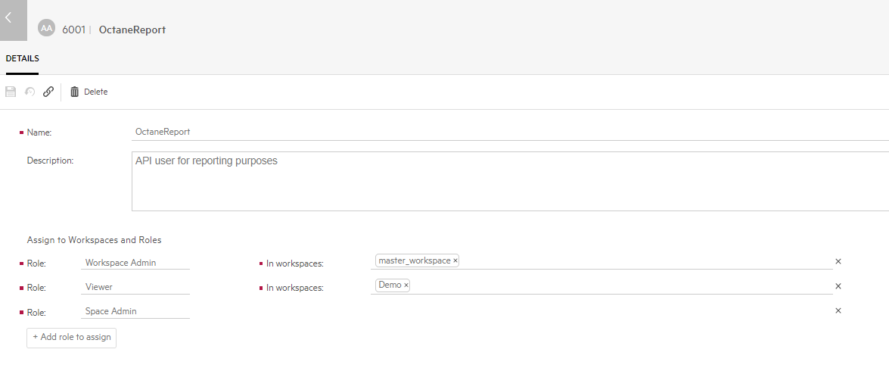

1. Install the ALM Connectivity for your ALM instance:

https://<servername>/qcbin/TDConnectivity_index.html

1. Bring up the Excel macro.
2. Click on the “Export Users from ALM” and enter your login credential.
3. Select your project to retrieve the users information. Click on Run.

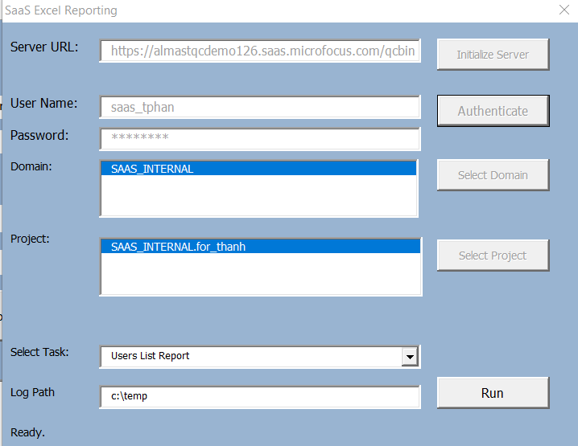

1. Click on the “Users List” and review the information. You may need to correct the user information if needed. Do a replace of the groups in ALM with the groups in Octane. When you import the user to Octane, it will look at the group column to determine which group the users should be added to. If in doubt, then just add the users to the Viewer group.
2. Enter the Octane server information

Example:

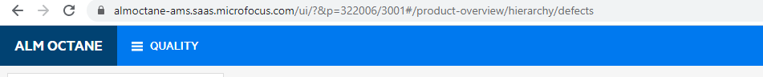

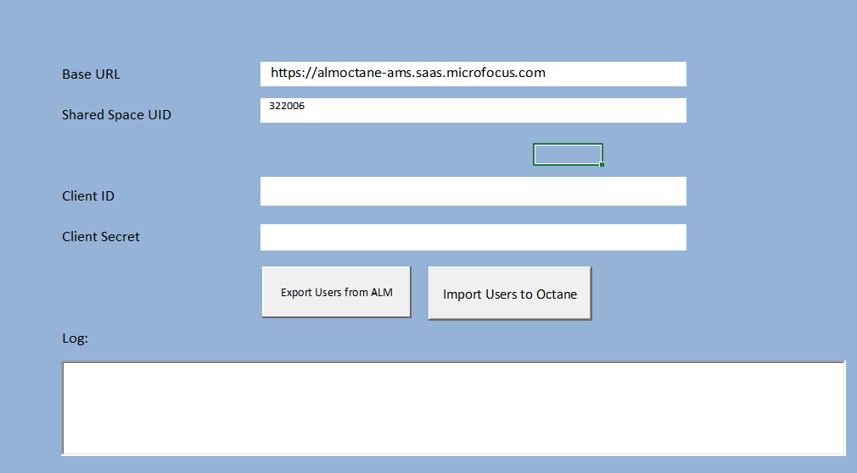

1. Click on “Import Users to Octane” button to import the users to the Octane shared space.